## AYALA ALABANG R1P

**1.1 Fire protection and safety audit**

1.1.1 Fire detection and alarm system

Summary of data and information from FDAS audit is presented in Table 1.1 with visual images on as-found devices and panels (Figure 1.1)

1.1.1.2 Recommendations

The findings/facts and results of the audit are presented in Table 1.1. Visual images of assets

are shown in Figure 1.1

Table 1.1 FDAS Data highlights



On the inspection date, it was established that there is Fire Alarm Control , **PYGARD brand** and the devices are SMOKE DETECTOR **“PYGARD”** brand.

It is a conventional fire alarm system which is an early warning system design that detects a fire, that tells the zone/ area of the fire but not the exact location of the fire. The existing design plan did not consider where a specific fire alarm can signal exactly where the fire is occurring.

The existing Fire Detection and Alarm system consists of:

20 pcs of smoke detector,

4 Zones indicator (Annunciator)

5 sets manual call point and buzzer

4 pcs bell

On the testing date, the activity was witnessed by the operator on duty for this pump station.

Figure 1.2 : Fire detection and alarm system

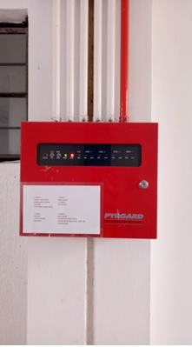 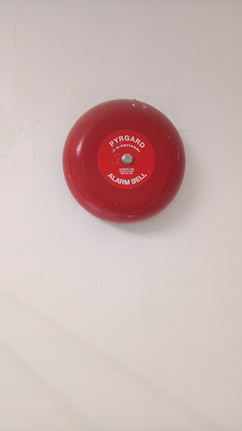 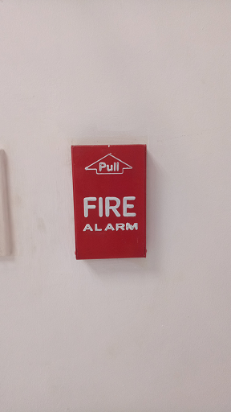 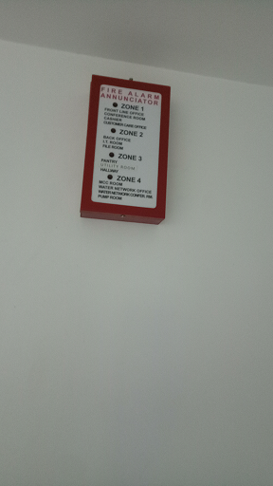

(a) FDAS panel (b) Bell (c) Manual pull station (d) Annunciator

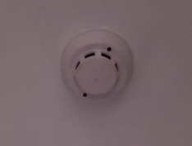 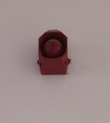

(e) Smoke Detector (f) Sounder

Highlights of the testing are:

* 16 out of 20 smoke detector devices were tested, activated after spraying of smoke tester. Location of functioning SD are
  + the lobby
  + hallway
  + conference room
  + file room
  + back room
  + pantry
  + customer care
  + utility room
  + Motor control center room
  + Water network room
  + Water network conference room
* Remaining 4 devices not tested due to unavailability of keys in the IT room, cashier room, and need scaffolding in the pump room
* All manual call point in good condition
* Three (3) bells were activated every time the smoke detectors and manual call point were activated
* One (1) bell device did not function (not activated-no sound) during testing located at the MCC room.
* There are no smoke detectors at the chlorine tank house and genset room.

Recommendation:

Troubleshoot non-functioning bell at the MCC room. Check wiring specially on the termination.

Figure 1.2 : Testing of smoke detectors

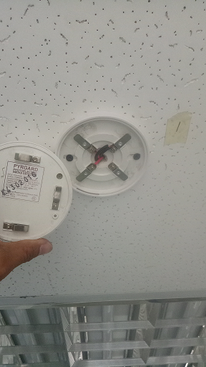 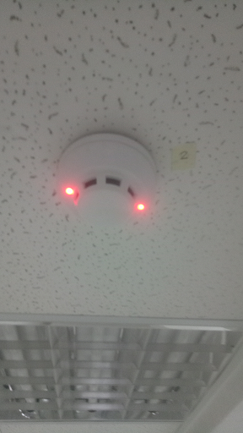 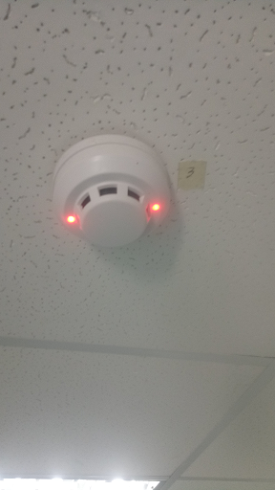 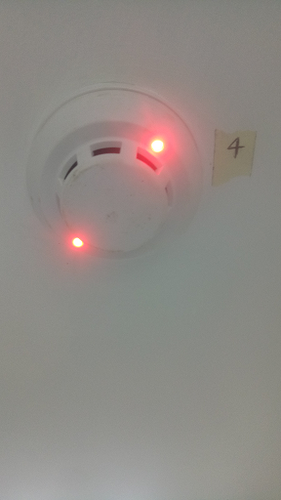

**SD#1 SD#2 SD#3 SD#4**

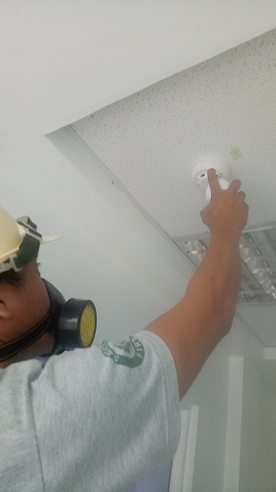 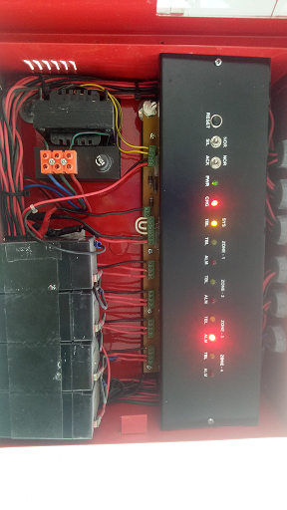 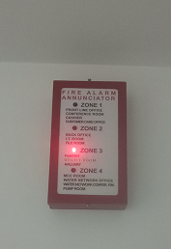 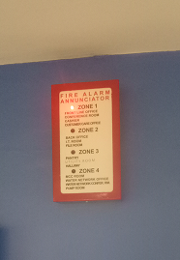

**Spray test of SD’s FA Control Panel Annunciator 1 Indication Annunciator 2 Indication**

**1.2 Lightning protection system**

There is a lightning protection system installed for this in pump station. The strike counter has registered previous strikes. Testing the connection of the continuity of bare copper wire connecting the lightning arrester indicated acceptable values but already on the marginal side.

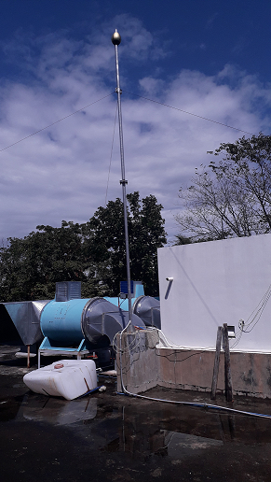 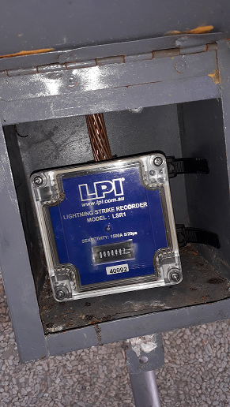 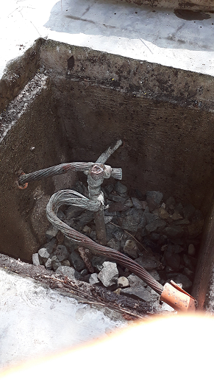

a. Lightning arrester rod b. Strike Counter c. Bare copper wire

1.3.3 Ground-Fault circuit interrupter (GFCI) or electric leakage circuit breaker (ELCB) or Residual circuit devices (RCD)

No GFCI or ELCB or RCD were installed in this booster station.

1.3.4 Electrical safety and protective devices APSI to write here the ﬁndings.

**ELECTRICAL SAFETY**

The pump station in general is well maintained, and the area station where the operator stays is free from all obstructions. There were some marginal findings of safety issues but otherwise the station is well managed. The station has observed good housekeeping and cleanliness of the pump station.

Table: Fire Protection Data Highlights



Figure: Fire protection data highlights

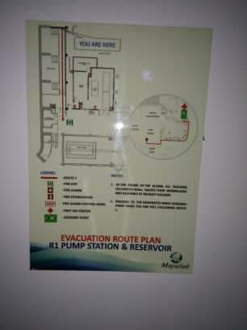 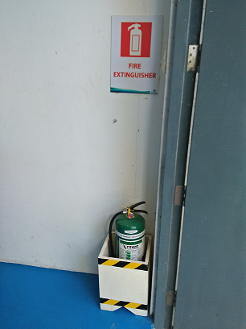 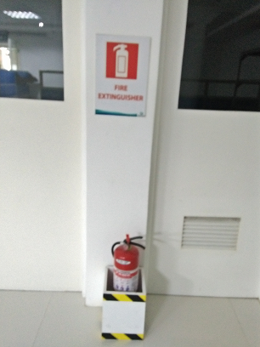

(a) evacuation plan (b) fire extinguisher – green (c) fire extinguisher-red

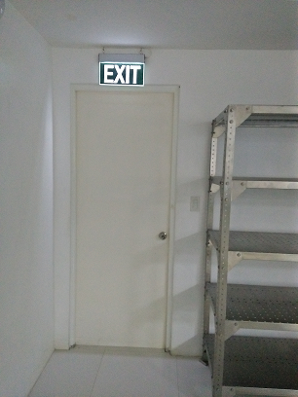 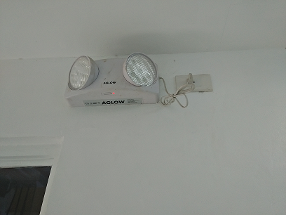

(d) exit signage (e ) emergency light

Table : Electrical Safety Findings



 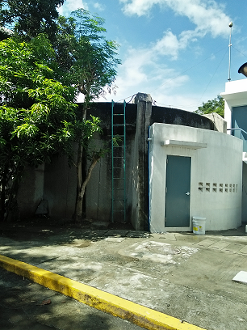

(a) Emergency light w/o inspection tag (b) Ladder w/o cage protection

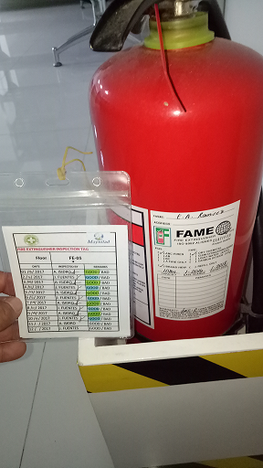 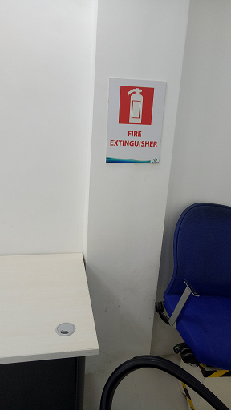

(c) FE-05 tag 10/4/2017 (d) No FEX on designated location

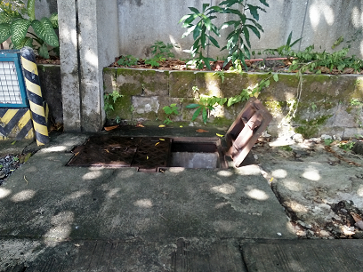 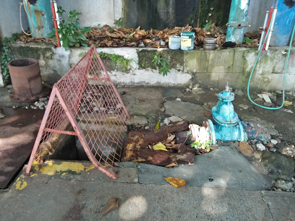

(e) Open manhole w/o barricade and w/o signage (f) Open manhole w/ barricade but w/o signage

**1.4 Conceptual Design and Outcomes**

**1.4.1 Basis of Design**

